**DRAFT**

**PLEASE DO NOT DISTRIBUTE**



**Documenting Company Culture Practices**

**A Template**

**Gerald R. Wagner, PhD**



Following below is a template that could be used as a reference for collecting and documenting data about company culture practices. The template is a starting place for a company to prepare their own template. The template has 44 sub-categories of culture practice data. That is way beyond what any company would want to include.

Some parts might be deleted, some combined, others added, and some kept intact but left empty in anticipation of having data at a later time. The user(s) are company employees that are part of a culture committee or culture ambassador group.

When a template is final for a particular company group, then collect supporting data for the culture categories which could be in the form of reports, references, opinions, policies, memos, presentations, papers, meeting minutes, tools, methods, procedures, surveys, and others that give insight to a company’s culture practices.

As data is accumulated it could be input to an online software tool where all employees continue documenting, contributing, and sharing. Employees then can know the ins and outs of their company’s culture. This is consistent with being transparent, one of the most important culture practices.

The following is a draft mockup for what an employee’s computer screen might look like with the software. This screen would be for showing a sub-category called Peer to Peer Recognition within a sub-category called Employee Connections:

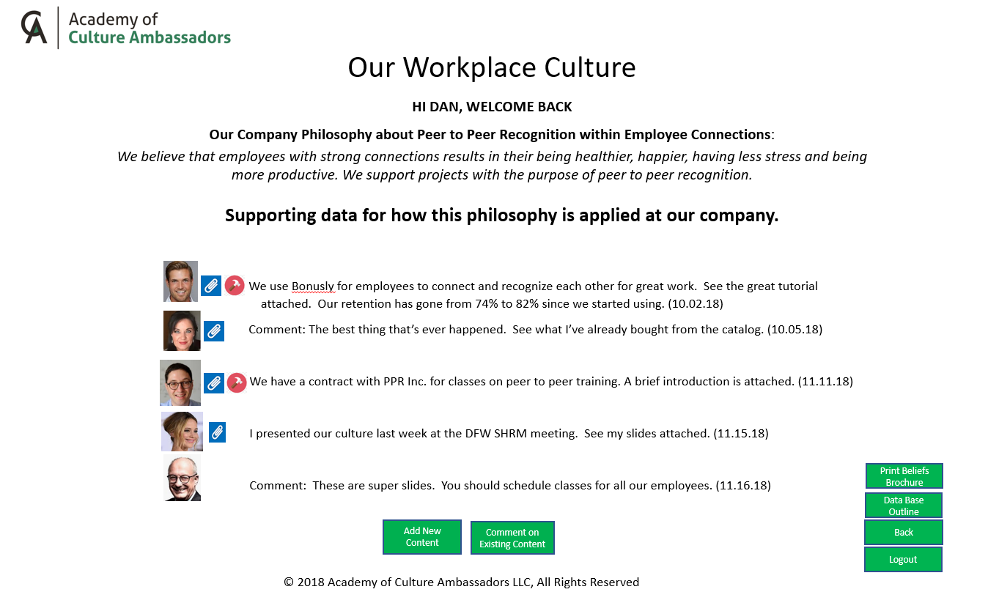

Also, a brochure could be printed with the company philosophy for each practice area. This would be useful in a variety of ways including recruiting and for customers. The returning emphasis on high quality hard copy printing this will become more important.

With the above thinking, an online template with computer software could be the “one place”:

* That holds data about a company’s culture.
* Where every employee can access culture data about their company and add to it.
* To see what and where culture practices might be implemented or improved.
* To learn about the breadth of culture practices, tools, methods, and processes.
* To print a hard copy brochure with company philosophy for each practice area.

Please take time to review the template. Suggestions for changes and additions will be most welcome. Send your suggestions to Jerry Wagner at [cultureambassadorsinc@gmail.com](mailto:cultureambassadorsinc@gmail.com)**.**

**Culture Practice Template**

|  |  |
| --- | --- |
| The Company | |
| *Area* | *Notes and Web Sites for Tools* |
| **Vision**   * Our company philosophy * Supporting data for how this philosophy is applied at our company |  |
| **Mission**   * Our company philosophy * Supporting data for how this philosophy is applied at our company |  |
| **Purpose**   * Our company philosophy * Supporting data for how this philosophy is applied at our company |  |
| **Sustainability**   * Our company philosophy - beliefs and principles that the company strives for * Supporting data for how this philosophy is applied at our company |  |
| **Financial Objectives**   * Our company philosophy - beliefs and principles that the company strives for * Supporting data for how this philosophy is applied at our company |  |
| **Hierarchy**   * Our company philosophy - beliefs and principles that the company strives for * Supporting data for how this philosophy is applied at our company   Examples of data:   * Flat * Distributed decision making * Matrix training | Culture Management  <https://www.workxo.com/> |
| **Employees Treated as Owners**   * Our company philosophy - beliefs and principles that the company strives for * Supporting data for how this philosophy is applied at our company   Examples of data:   * Programs * Participation statistics * Requisites * Stock ownership |  |
| **Customer Attention**   * Our company philosophy - beliefs and principles that the company strives for * Supporting data for how this philosophy is applied at our company |  |
| **Office Layout**   * Our company philosophy - beliefs and principles that the company strives for * Supporting data for how this philosophy is applied at our company   Examples of data:   * Open doors * Art * Colors * Light * Collaboration space * Stand up desks |  |
| **Artifacts**   * Our company philosophy - beliefs and principles that the company strives for * Supporting data for how this philosophy is applied at our company   Examples of data:   * Awards * Advertisements * Press * Photos |  |
| **Organizational Chart**   * Our company organization chart |  |
| **Workplace** | |
| **Responsibilities, Expectations and Accountability**   * Our company philosophy - beliefs and principles that the company strives for * Supporting data for how this philosophy is applied at our company   Examples of data:   * Accountability metrics * Job description templates * Tools |  |
| **Flexibility**   * Our company philosophy - beliefs and principles that the company strives for * Supporting data for how this philosophy is applied at our company   Examples of data:   * Freedom for work scheduling * Team assignment * Decision making |  |
| **Work Teams**   * Our company philosophy - beliefs and principles that the company strives for * Supporting data for how this philosophy is applied at our company   Examples of data:   * Changing teams * Assignment to teams * Process to change |  |
| **Individual Strengths**   * Our company philosophy - beliefs and principles that the company strives for * Supporting data for how this philosophy is applied at our company   Examples of data:   * Alignment with job * Development training * Tools | Strengths:  <https://www.gallupstrengthscenter.com/>  <https://www.strengthscope.com/>  <https://culturetalk.com/>  <https://www.discprofile.com/what-is-disc/overview/>  <http://www.dreamleadershipconsulting.com/> |
| **Fair and Equitable Financial Rewards**   * Our company philosophy - beliefs and principles that the company strives for * Supporting data for how this philosophy is applied at our company   Examples of data:   * Fair and equitable * Review process * Asking for review |  |
| **Autonomy**   * Our company philosophy - beliefs and principles that the company strives for * Supporting data for how this philosophy is applied at our company   Examples of data:   * Freedom in decision making * Accountability * Risk tolerance |  |
| **Employee Performance** | |
| **Evaluations**   * Our company philosophy - beliefs and principles that the company strives for * Supporting data for how this philosophy is applied at our company   Examples of data:   * Process * Effectiveness * Requesting review * Transparency * Tools | Engagement Survey  <http://blessingwhite.com/> |
| **Attracting and Keeping Employees** | |
| **Recruitment and Retention**   * Our company philosophy - beliefs and principles that the company strives for * Supporting data for how this philosophy is applied at our company   Examples of data:   * Culture as a tool in recruiting * Culture as a tool for in-boarding * Culture as a tool for retention * History/Heritage * Tools |  |
| **Transparency** | |
| **Sharing Data**   * Our company philosophy - beliefs and principles that the company strives for * Supporting data for how this philosophy is applied at our company   Examples of data:   * How decisions are made * Open meetings * Meeting training * Financial scorecards * Training on financial data * Culture survey’s * Tools | Financial training  <https://www.daveramsey.com/courses> |
| **Values and Behaviors** | |
| **Values**   * Our company philosophy - beliefs and principles that the company strives for * Supporting data for how this philosophy is applied at our company   Examples of data:   * Values * Definitions * Metrics * Tools | Values  <https://coetichr.com/core-values-tool/> |
| **Organizational Behaviors**   * Our company philosophy - beliefs and principles that the company strives for * Supporting data for how this philosophy is applied at our company   Examples of data:   * Beliefs * Behaviors * Definitions * Metrics * Tools |  |
| **Work Team Behaviors**   * Our company philosophy - beliefs and principles that the company strives for * Supporting data for how this philosophy is applied at our company   Examples of data:   * Expected behaviors * Definitions * Metrics * Tools |  |
| **Behavioral Practices**   * Our company philosophy - beliefs and principles that the company strives for * Supporting data for how this philosophy is applied at our company   Examples of data:   * Participation statistics * Marketing * Tools | Behavior Practices  <https://www.amazon.com/My-31-Practices-Authentic-Happiness/dp/1907794352> |
| **Communication** | |
| **Sharing**   * Our company philosophy - beliefs and principles that the company strives for * Supporting data for how this philosophy is applied at our company   Examples of data:   * Sharing goals * Sharing progress * Leader roundups with employees * Town halls * Pulse checks * Addressing feedback * Newsletters * Tools | Collaboration  <https://www.igloosoftware.com/>  [https://www.mytractiontools.com](https://www.mytractiontools.com/) |
| **Employee Connections** | |
| **Peer to Peer Mentoring**   * Our company philosophy - beliefs and principles that the company strives for * Supporting data for how this philosophy is applied at our company   Examples of data:   * Program * Participation statistics * Testimonials * Training * Tools |  |
| **Peer to Peer Recognition**   * Our company philosophy - beliefs and principles that the company strives for * Supporting data for how this philosophy is applied at our company   Examples of data:   * Participation statistics * Earning rewards * Tools | Recognition:  <http://www.myohos.com/>  <https://bonus.ly/>  <https://youearnedit.com/>  <https://www.globoforce.com/> |
| **Team Building** | |
| **Projects for Comradery, Fun and Team Building**   * Our company philosophy - beliefs and principles that the company strives for * Supporting data for how this philosophy is applied at our company   Examples of data:   * Marketing * Team building * Identifying activities * Management * Participation statistics * Photos * Budget |  |
| **Community Volunteering**   * Our company philosophy - beliefs and principles that the company strives for * Supporting data for how this philosophy is applied at our company   Examples of data:   * Identifying activities * Marketing * Management * Participation * Executive support * Service days * Photos |  |
| **Celebrations and Retreats**   * Our company philosophy - beliefs and principles that the company strives for * Supporting data for how this philosophy is applied at our company   Examples of data:   * Leadership retreats * Holidays * Birthdays * Births * Photos |  |
| **Culture Clubs**   * Our company philosophy - beliefs and principles that the company strives for * Supporting data for how this philosophy is applied at our company   Examples of data:   * Charter * Management * Newsletter * Photos * Participation statistics * Budget |  |
| **Employee Creativity** | |
| **Innovation**   * Our company philosophy - beliefs and principles that the company strives for * Supporting data for how this philosophy is applied at our company   Examples of data:   * Encouragement * Incentives * Recognition * Awards * Participation statistics |  |
| **Idea Management**   * Our company philosophy - beliefs and principles that the company strives for * Supporting data for how this philosophy is applied at our company   Examples of data:   * Participation statistics * Suggesting ideas * Asking questions * Access * Processing * Feedback * Tools | Idea Management  <https://www.brightidea.com/company/> |
| **Health and Wellbeing** | |
| **Health and Wellness**   * Our company philosophy - beliefs and principles that the company strives for * Supporting data for how this philosophy is applied at our company   Examples of data:   * Emergency facilities * Incentives * Challenge programs * Food * Drinks * On-site medical facilities * Education * Health fairs * Tools |  |
| **Consideration of the Whole Person**   * Our company philosophy - beliefs and principles that the company strives for * Supporting data for how this philosophy is applied at our company   Examples of data:   * Mental health * Parental leave * Child care * Participation statistics * Adoptions * Spiritual |  |
| **Mindfulness**   * Our company philosophy - beliefs and principles that the company strives for * Supporting data for how this philosophy is applied at our company   Examples of data:   * Meditation * Participation * Quiet space * Yoga * Participation Statistics * Tools | Mindfulness  <http://www.iamherenow.com/> |
| **Healthy Attitudes**   * Our company philosophy - beliefs and principles that the company strives for * Supporting data for how this philosophy is applied at our company   Examples of data:   * Forgiveness * Kindness * Compassion * Love * Trust * Promoted * Practices * Honoring * Tools | Kindness  <http://www.oliviamcivor.com/booksproductschange-tools.html>  Trust  <https://leabrovedani.com/books/> |
| **Personal Wellbeing**   * Our company philosophy - beliefs and principles that the company strives for * Supporting data for how this philosophy is applied at our company   Examples of data:   * Round tables with Gallup’s book * Dream Manager(s) * Coaches | Personal Wellbeing  <https://www.gallup.com/workplace/237020/five-essential-elements.aspx>  <http://www.spendlifewisely.com/pillars/personal-growth/the-power-of-ted>  <https://www.franklincovey.com/the-7-habits.html> |
| **Development** | |
| **Job Skills**   * Our company philosophy - beliefs and principles that the company strives for * Supporting data for how this philosophy is applied at our company   Examples of data:   * Classes * Process to request * Process to participate * Participation statistics * Growing others * Calendar * Tools |  |
| **Professional**   * Our company philosophy - beliefs and principles that the company strives for * Supporting data for how this philosophy is applied at our company   Examples of data:   * Vetting * Applying * Participation statistics * Teach back * Calendar |  |
| **Leadership**   * Our company philosophy - beliefs and principles that the company strives for * Supporting data for how this philosophy is applied at our company   Examples of data:   * Classes * Applying * Teach back * Calendar * Tools | Conference  <https://www.humansynergistics.com/>  <https://www.octanner.com/>  <http://cultureambassadorsretreat.com/>  <https://www.workhuman.com/>  <https://www.amazon.com/Humanocracy-Creating-Organizations-Amazing-People/dp/1633696022> |
| **Internal and External Classes**   * Our company philosophy - beliefs and principles that the company strives for * Supporting data for how this philosophy is applied at our company   Examples of data:   * Vetting * Applying * Participation statistics * Teach back * Calendar |  |
| **Other Opportunities**   * Our company philosophy - beliefs and principles that the company strives for * Supporting data for how this philosophy is applied at our company   Examples of data:   * Participation statistics * Walk in the shoes of others * Shadowing * Peer coaching |  |
| **Community Awareness** | |
| **Branding**   * Our company philosophy - beliefs and principles that the company strives for * Supporting data for how this philosophy is applied at our company   Examples of data:   * Marketing * Consistency * Testing recognition * Tools | Branding  <https://buildingastorybrand.com/>  https://create.piktochart.com/ |
| **Customers** | |
| **Marketing Messaging**   * Our company philosophy - beliefs and principles that the company strives for * Supporting data for how this philosophy is applied at our company   Examples of data:   * Culture in marketing promotions * Culture in sales * Tools | <https://www.josephmichelli.com/bestsellers/> |
| **Loyalty and Retention**   * Our company philosophy - beliefs and principles that the company strives for * Supporting data for how this philosophy is applied at our company   Examples of data:   * Feedback * Tracking repeat business * Actions to correct * Tools | Net Promoter Scores  <https://www.zendesk.com> |

The following is intended as a brief outline of “what now?”

**How to use this template**

First, review the breadth of culture practices. It’s a lot of stuff but don’t become overwhelmed. Remember that culture touches every person and everything in every company, so it is broad.

**How to form a team of employees to get started creating a custom template**

Determine what employees have shown or expressed interest in workplace culture. Have a way to announce to all employees that the company wishes to know about these people. From this is formed a team to continue review.

**How to create a unique custom template**

The team gathers with a consultant that is knowledgeable with the breadth of template. The consultant explains elements that the team is not familiar with. The team and consultant go through the template and check those elements for which they know the company has data for and/or should be further looked into, edits what exists, and adds new ones. From this they arrive at a template outline for their company.

**Documenting company culture practice data**

The team has now chosen their unique template with elements to be documented. They decide who is assigned what data to collect, agree on a schedule and how to keep each other informed of progress.

**Entering data into the culture practices data base**

The team is briefed on how to enter data into the software system.

**Engage all employees**

Employee classes are held to explain the template and train employees to use the software.

If you would like to talk about the contents of this paper, please contact Jerry Wagner at [wagnergeraldr@gmail.com](mailto:wagnergeraldr@gmail.com). In case you don’t know, he is the CEO of the Academy of Culture Ambassadors that sponsors the Workplace Wisdom retreat.